School:

Name:

Subject:

From the histogram curve below, the distribution of male as displayed by the curve shows there is normal distribution of male in the final exam in terms of the correct answers. As its evidence that the curve portrays a normal curve.
Checking at female distribution. It is not clear because we have two shape which we can refers to as undefined or bi-modal. The distribution is not normal as we have different peak in the dataset.

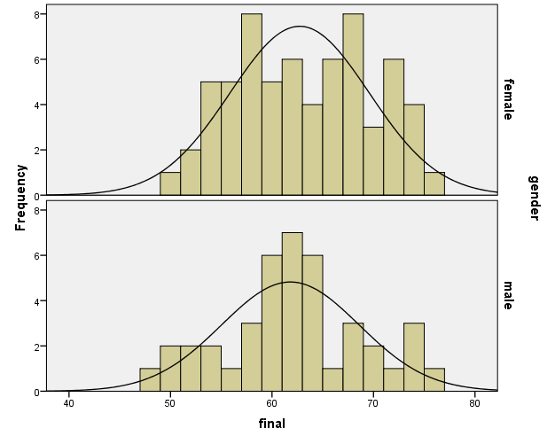

Part 2.
- The mean value of grade point is 2.9098, skewness of -.228 and kurtosis of -0.757.
The mean of correct answers is 7.26, skewness of 0.106 and kurtosis of -0.511.

- Skewness basically measures the distribution of the data such that, it assesses the symmetric nature of dataset while kurtosis is a measure of whether the data is heavily tailed or relatively tailed to a normal distribution.
From the descriptive table below, previous grade point shows negative value indicating there is more distribution of the grade points to the left than to the right of a normal distribution curve.Number of correct answers shows a positive skewness indicating that there is more distribution of the correct answers on the right tail of a normal curve that is correct answers are Positively skewed.
Looking at kurtosis values of grade points and the correct answers they are all negative which indicate that the outlier character of our grade dataset is less extreme on the aspect of the two variables of interest in expectations that the data came from a normal distribution.

